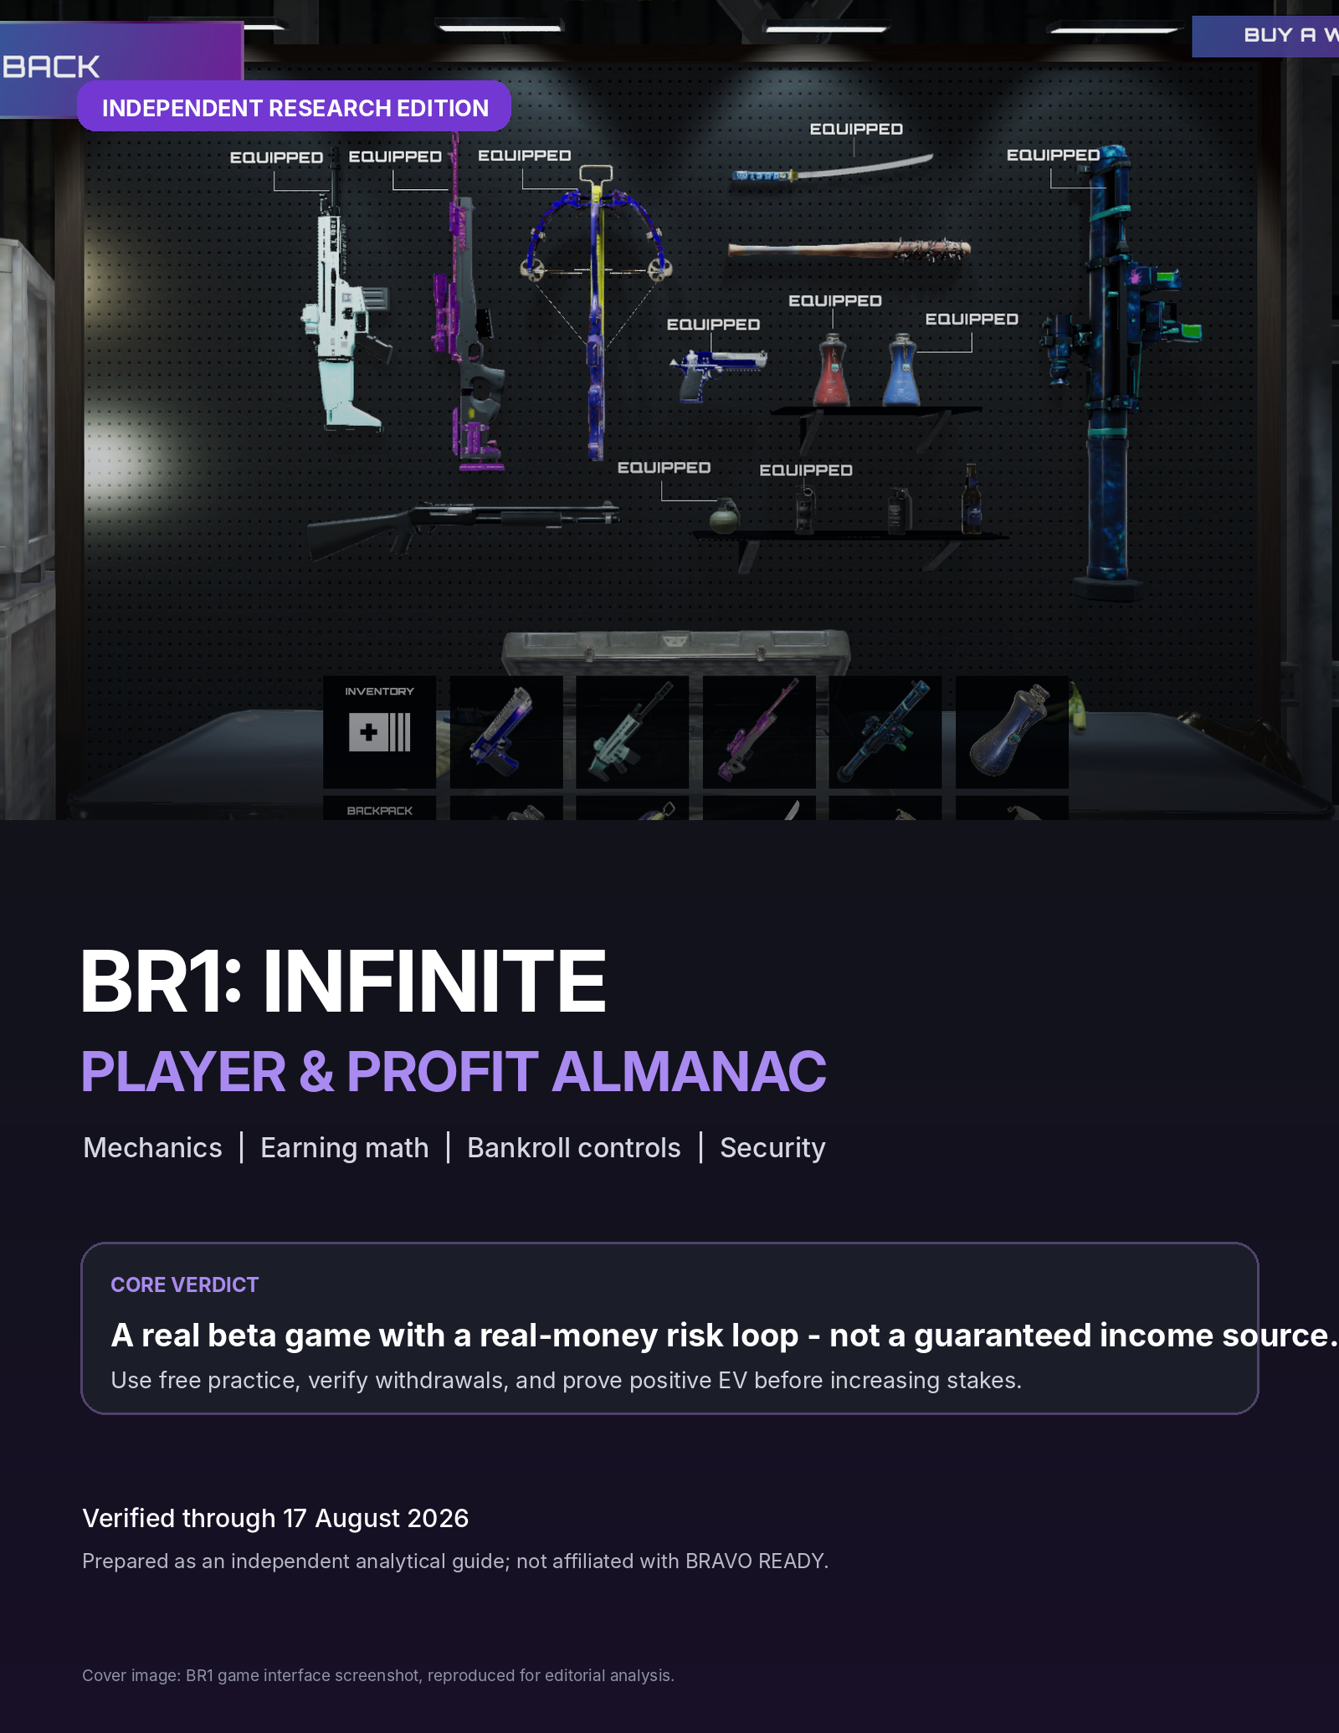

Executive verdict
What the research supports - and what it does not.
BOTTOM LINE
BR1: INFINITE appears to be a genuine, playable beta product with a traceable publisher and a functioning real-money game economy. It should still be treated as speculative paid competition, not a job or dependable side income. The player must fund every paid spawn, the platform keeps a service fee, and the game remains exposed to access, player-liquidity, cheating, withdrawal, legal, and beta-change risk. ^{[S1, S2, S8, S11]}

PRODUCT EXISTS | PAYOUTS: CLAIMED | INCOME: NOT GUARANTEED | BETA RULES CAN CHANGE

Research verdict by category
Category | Assessment | Why it matters
Corporate traceability | Strong | Canadian operating entity, Montreal publisher, named executives and disclosed investors.
Gameplay / access | Moderate | Official site calls it open beta; recent reporting describes invite-only or timed playtests.
Core rule transparency | Moderate | Official guide publishes the fee, ERB, Survival and extraction formulas, but some live-status figures conflict across pages.
Payout confidence | Moderate-low | Withdrawals are contemplated in the Terms and the studio claims over $100,000 paid, but no independent reserve or payout audit was located.
Anti-cheat confidence | Low-moderate | A development vendor states server-authoritative hit registration, but no public full anti-cheat architecture or victim reimbursement policy was found.
Reliable income potential | Low | A positive result requires sustained K/D above the fee-adjusted threshold, sufficient opponents, stable access, and successful withdrawals.

The six facts to remember
1 | You pay to spawn. A death with zero kills loses the full spawn fee.

2 | One kill is not automatically profitable. If you die after one kill, the service fee still leaves a small loss at both 0% and 15% ERB. ^{[S2, S3]}

3 | Survival reduces risk; it does not erase it. A successful Survival returns 50% of the spawn fee, so a zero-kill survival still loses half the stake. ^{[S2, S3]}

4 | The official planning threshold is about 1.30 K/D. The guide states 1.30 K/D without max ERB and 1.13 K/D with max ERB as the minimum profitability targets. ^{[S2, S3]}

5 | $10/hour is not a guaranteed mechanic. It is a viral claim. Verified earnings come from eliminations, secured Cash Drops, Survival premium, and event rewards.

6 | The live client outranks old guides. Risk tiers, access status, withdrawal minimums and schedules have conflicting public descriptions.

Almanac index
Use the document in order for onboarding, or jump to the decision you need.
01 | Current status and access | Beta state, platform, conflicting public status, and safe download path.
02 | The game loop | Free practice, risk servers, eliminations, Cash Drops, Survival and respawning.
03 | Controls and field reference | Verified key controls, inventory, Survival timer and weapon classes.
04 | Every earning channel | Kill earnings, cash extraction, events, pass, points, assets and rentals.
05 | Profitability mathematics | Exact formula, break-even conditions and per-life outcome tables.
06 | $10/hour reality check | Modeled hourly outcomes and the performance needed to reach the viral claim.
07 | Bankroll protocol | Stake sizing, stop-losses, promotion rules and recordkeeping.
08 | Low-variance tactical playbook | How the payoff structure changes combat and extraction decisions.
09 | Operatives, ERB and asset economics | How to value bonuses without overpaying for NFTs or rentals.
10 | Infinite Pass, Points and loot boxes | Reward systems, posted drop rates, and expected-value cautions.
11 | Deposits, wallets and withdrawals | USDC-SPL, KYC, threshold conflicts and a safe cash-out test.
12 | Security and anti-cheat risk | Wallet safety, account risk, cheating controls and evidence preservation.
13 | Legal and U.S. tax checklist | Age/location eligibility, jurisdictional risk and recordkeeping.
14 | Publisher and legitimacy assessment | What is verified, what is claimed, and what remains missing.
15 | Seven-day onboarding plan | A controlled experiment that limits capital at risk.
16 | Quick-reference sheets | Formulas, decisions, glossary, due-diligence questions and sources.

01 Current status and access
The first risk is not gameplay - it is relying on stale or conflicting information.
The official BR1 site currently labels the product "OPEN BETA PHASE," offers account signup, and presents a PC download path. Recent August 2026 coverage, however, describes access as invite-only, closed beta, or limited-time playtests. The practical conclusion is that account creation may be open while actual server access can still be gated by invites or scheduled windows. ^{[S1, S11, S12]}
ACCESS RULE
Use only the official BR1 website and the launcher delivered after official signup. Do not install the client from software-download aggregators, social-media file links, or unsolicited Discord direct messages. ^{[S1, S8]}

Public-status discrepancy ledger
Item | What current sources say | Operational rule
Beta phase | Official site: open beta. Recent media: invite-only / timed playtests. | Create an account, but assume access can be scheduled or restricted until the launcher confirms otherwise.
Risk tiers | Homepage: $0.10, $0.25, $1, $5. Guide: $0.25, $0.50, $1, $5. | Treat the live server-select screen as authoritative. Never pre-plan a bankroll around an unavailable tier.
Epic Games Store | Recent coverage mentions a wishlist page; the direct listing checked during research returned an unavailable page. | Use BR1's own launcher unless an official BR1 announcement provides a working store listing.
Withdrawal minimum | Legal Terms: at least $10. Older preseason material and coverage: $25. | Read the live withdrawal screen before depositing and test the smallest permitted withdrawal.
Token status | Current economy centers on USDC-SPL and BR1 Points. Older material discusses a future $BR1 token. | Do not buy any token merely named BR1; require a current official contract/mint address.

Verified platform profile
Attribute | Current research finding
Genre | Third-person, persistent extraction / "Infinite Royale" shooter.
Platform | PC via BR1 launcher; no verified console or mobile version.
Network / settlement | Solana ecosystem; current guide describes USDC-SPL deposits and withdrawals.
Practice mode | Free servers for practice and leveling.
Paid mode | Risk servers with a separate spawn fee for each life.
Age gate | 18+ under the Terms of Use.
Geographic gate | Must be physically located in a jurisdiction where the platform is permitted.
No dependable current PC hardware specification sheet was located in the official materials reviewed. Test the free server on the exact machine, network, resolution and input setup you intend to use before paying for any spawn.

02 The game loop
BR1 converts every paid life into a small, measurable risk position.
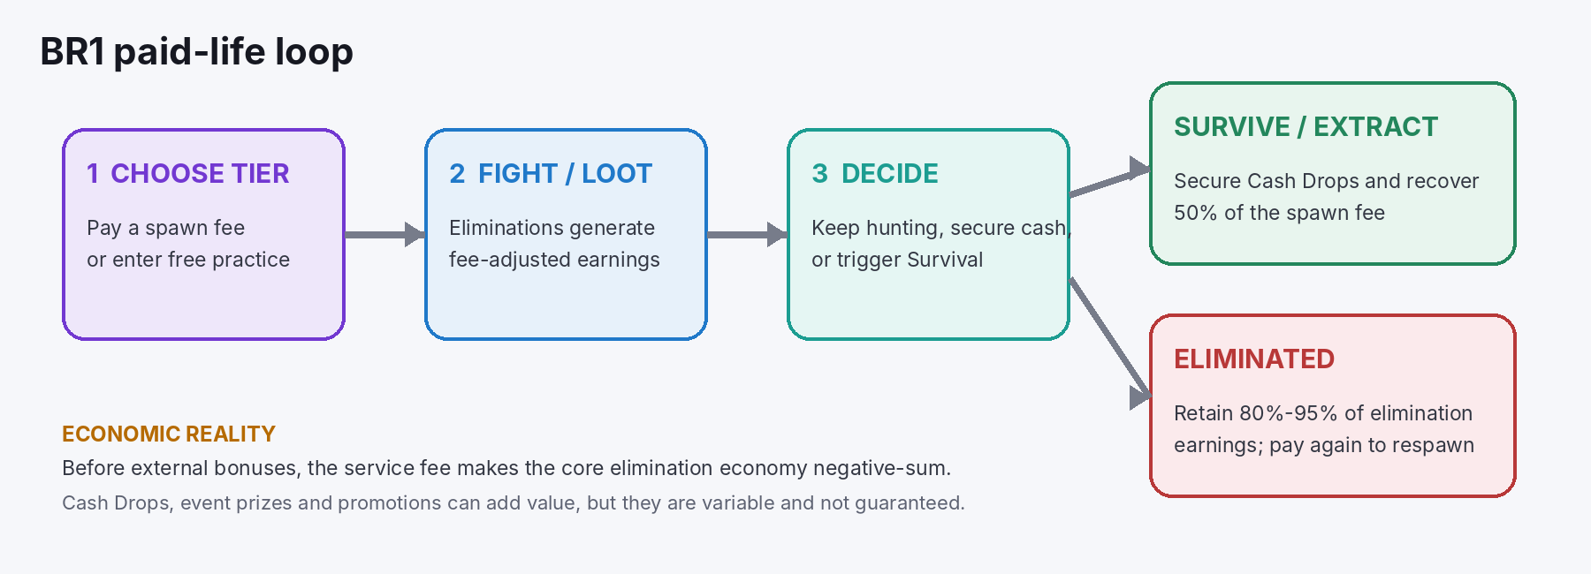
The economic loop derived from BR1's current guide and Terms.
Source basis: official BR1 site and guide [S1-S4].

Risk servers versus free servers
Free servers are intended for practice and leveling. Risk servers charge a spawn fee and pay elimination earnings at the same nominal tier before the service fee and ERB are applied. Official guide tiers currently list $0.25, $0.50, $1 and $5; the homepage separately lists $0.10, $0.25, $1 and $5. ^{[S1, S2]}

The four outcomes that move money
Outcome | Economic effect | What can go wrong
Eliminate a player | Gross tier value is adjusted by the 80% base retention plus ERB. | You can still be killed later; a single kill may not cover the entry fee.
Collect a Cash Drop | Adds its cash value only after it is secured through extraction. | If eliminated first, another player can loot it.
Survive / extract | Returns 50% of the spawn fee and secures eligible cash. | The Survival action requires a full timer and a vulnerable stationary countdown.
Get eliminated | The life ends; you retain 80%-95% of elimination earnings and must pay again to respawn. | Zero kills means the full entry fee is lost.
NEGATIVE-SUM STRUCTURE
Before Cash Drops, promotional subsidies or prize pools, the elimination economy is negative-sum because the platform keeps a service fee. The fee is effectively 20% at zero ERB and can be reduced to 5% at maximum 15% ERB. ^{[S3, S5]}

What "infinite" means
The server is persistent rather than a conventional match with a fixed start, shrinking circle and final winner. A player enters an already-live environment, stays until eliminated or successfully exits through Survival, and pays again for another paid life. ^{[S2]}

03 Controls and field reference
Only controls and timing that could be verified in the current official guide are treated as authoritative.

Verified key controls
Action | Default control | Operational note
Open backpack | I or Esc | Drag stored weapons/items into the five-slot combat inventory.
Select inventory slot | 1-5 or mouse wheel | Build a predictable order so healing and utility are not mis-selected under pressure.
Trigger Survival | F10 | Available after the Survival bar fills; starts the 30-second exit countdown.
Movement / damage during exit | Avoid both | Movement or incoming damage interrupts the attempt; choose cover before pressing F10.

Survival timing
The current guide describes a yellow Survival bar that fills over five minutes. Once full, F10 starts a 30-second countdown. Completion exits the life, returns 50% of the spawn fee, and secures eligible extraction value. Older guides described a ten-minute bar; use the live HUD. ^{[S3]}
DECISION IMPLICATION
Once the bar is full, Survival is a risk-control option. It is especially valuable after one or more kills or after collecting cash; waiting for one more fight can convert a positive life into a loss.

Weapon and item classes
The official guide includes assault rifles, snipers, shotguns, handguns, bows, melee weapons, explosives and utility. Exact damage, fire-rate and range figures have changed across updates, so the live stat panel should be used for the current meta rather than older published damage tables. ^{[S6]}
- Assault rifles: general-purpose engagements; prioritize recoil consistency and ammunition availability.
- Shotguns and melee: high close-range payoff but large positional variance; unsuitable for forced pushes with cash on hand.
- Snipers and bows: lower exposure when sightlines are known, but missed shots can reveal position and consume time.
- Smoke, flash and explosives: treat as extraction-enabling tools, not only kill tools.
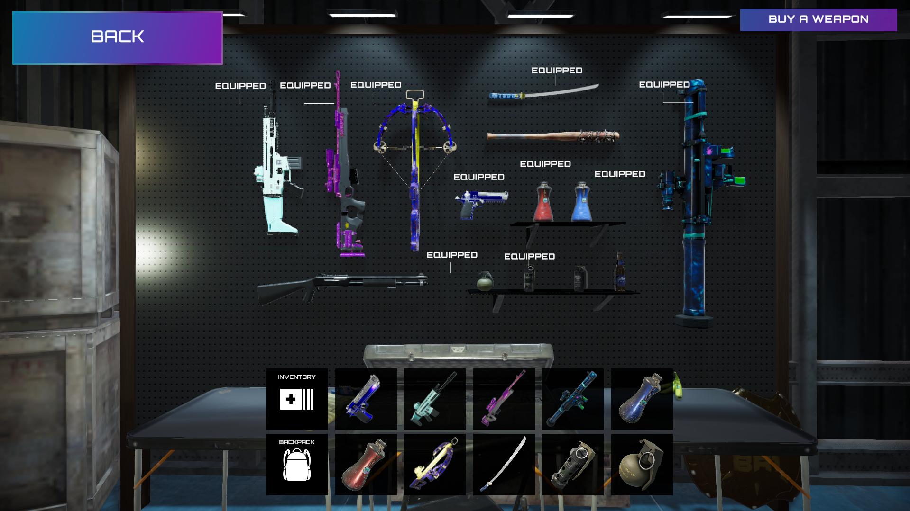
Example BR1 loadout and backpack interface.
Editorial screenshot source: PlayToEarn game listing [S11].

04 Every earning channel
Separate cash, conditional cash, points, digital items and promotional claims.
Channel | Cash status | Mechanic | Principal risk
Elimination earnings | Cash-denominated | Tier stake x kills x (0.80 + ERB). | Service fee, death, low K/D, cheating and player-pool quality.
Cash Drops | Conditional cash | Looted value is secured only through extraction. | Lost if another player eliminates and loots you first.
Survival premium | Cash-denominated | Successful Survival returns 50% of the spawn fee. | A zero-kill Survival still leaves a 50% stake loss.
Kill Races / events | Variable prize money | Daily, weekly or monthly competitive leaderboards when scheduled. | Prize pools, eligibility and schedule can change.
Infinite Pass | Rewards, items, XP, sometimes USDC | Seasonal progression; free during current preseason per guide. | Future paid tiers and reward tables are not fixed.
BR1 Points | Not current cash | Earned from play, renting, referrals, social activity and multipliers. | No guaranteed cash conversion or token value.
Operative / weapon assets | Tradable digital items | May provide ERB and be bought, sold or rented. | Price volatility, thin liquidity, counterparty and platform risk.
Welcome / promotional bonus | Promotional | Official signup currently advertises a $5 bonus. | Terms, availability and withdrawal restrictions can change.

Fact-check: the viral "$10 per hour" claim
Recent news and social posts repeat a $10-per-hour figure, but the official mechanics reviewed do not describe a guaranteed hourly wage. The verified system pays for eliminations, secured Cash Drops, Survival premium and scheduled competition rewards. Any hourly result is an output of your K/D, lives per hour, stake, ERB, extraction success and available opponents. ^{[S1, S2, S12, S13]}
CLASSIFICATION RULE
Treat USDC and withdrawable account balance as cash-like. Treat BR1 Points, loot boxes and unsold NFTs as speculative inventory with zero cash value until actually sold and withdrawn.

05 Profitability mathematics
Use the official formula first; use the official K/D threshold as the safer planning rule.
CORE FORMULA
For one paid life: Net = S x [K x (0.80 + E) - 1 + 0.50 x X] + C + P - W. Here S is spawn fee, K is eliminations, E is ERB from 0.00 to 0.15, X is 1 for successful Survival and 0 otherwise, C is secured Cash Drops, P is prizes/promotions, and W is any withdrawal, network or other cost. ^{[S3, S4, S5]}

Per-life result before Cash Drops and prizes
Life outcome | 0% ERB | 15% ERB | $1 tier / 0% | $1 tier / 15%
Eliminated, 0 kills | -1.00 x stake | -1.00 x stake | $-1.00 | $-1.00
Eliminated, 1 kill | -0.20 x stake | -0.05 x stake | $-0.20 | $-0.05
Eliminated, 2 kills | +0.60 x stake | +0.90 x stake | $+0.60 | $+0.90
Eliminated, 3 kills | +1.40 x stake | +1.85 x stake | $+1.40 | $+1.85
Survived, 0 kills | -0.50 x stake | -0.50 x stake | $-0.50 | $-0.50
Survived, 1 kill | +0.30 x stake | +0.45 x stake | $+0.30 | $+0.45
Survived, 2 kills | +1.10 x stake | +1.40 x stake | $+1.10 | $+1.40
Survived, 3 kills | +1.90 x stake | +2.35 x stake | $+1.90 | $+2.35
A one-kill death loses 20% of the stake at zero ERB and 5% at maximum ERB. A one-kill successful Survival earns 30% or 45% of the stake, respectively. This is why extraction discipline matters more than gross kill count. ^{[S3, S4]}

Break-even K/D
Measure | 0% ERB | 15% ERB | How to use it
Pure formula, death-case | 1.25 | 1.05 | Mathematical break-even with no cash, prizes, network costs or rule friction.
Official guide planning threshold | 1.30 | 1.13 | Use this more conservative target when deciding whether to risk money.
Recommended promotion buffer | 1.50+ | 1.35+ | Almanac risk rule over at least 100 paid lives at the lower tier.
DO NOT CONFUSE K/D WITH PROFIT
K/D ignores stake tier, Survival exits, Cash Drops, ERB acquisition cost, time per life, withdrawal friction and variance. Track actual net account change as the primary metric.

Worked official-style example
At a $1 stake, four eliminations, 12% ERB, $3 in secured Cash Drops and successful Survival: elimination earnings are 4 x $1 x (0.80 + 0.12) = $3.68; extraction cash is $3.00; Survival premium is $0.50; minus the $1 entry gives a $6.18 net life before any other cost. This matches the structure of the official guide example. ^{[S4]}

06 $10/hour reality check
A model, not a promise: the result changes sharply with K/D and activity rate.
The following model assumes a $1 stake, no Cash Drops, no event prizes, no withdrawal costs, and ten paid lives ending per hour. It uses the current 80%-95% elimination-retention range. Survival exits are excluded so the chart isolates the kill economy. ^{[S3]}
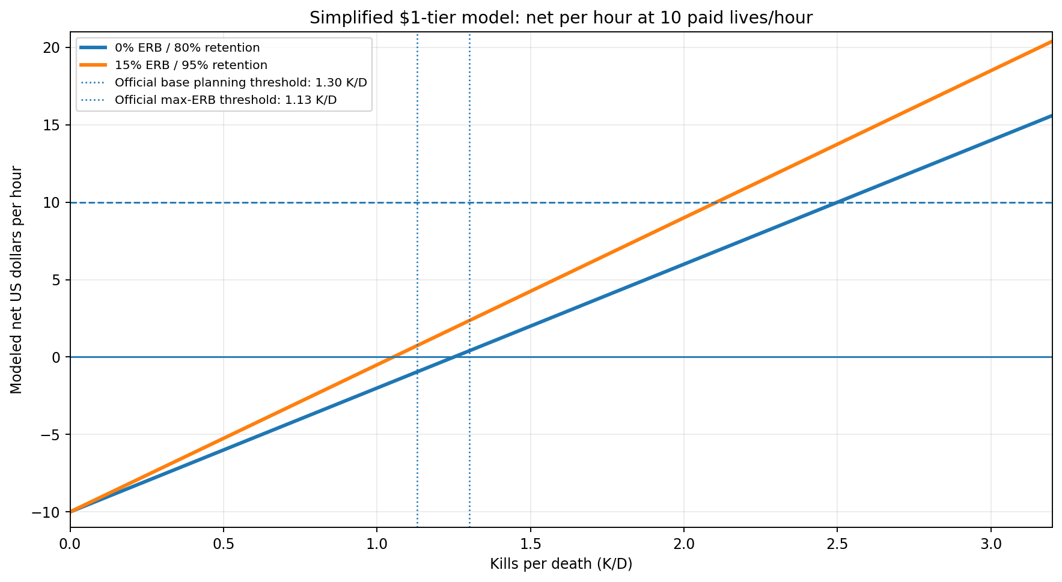
Modeled net per hour at ten paid lives/hour. This is not a forecast or guarantee.
K/D | Net/hr at 80% retention | Net/hr at 95% retention | Interpretation
0.5 | -$6.00 | -$5.25 | Rapid loss despite occasional kills.
1.0 | -$2.00 | -$0.50 | A 1:1 player still loses because of the service fee.
1.3 | +$0.40 | +$2.35 | Near the official base threshold; little margin for friction.
1.5 | +$2.00 | +$4.25 | Positive in the simplified model, but below the viral figure.
2.0 | +$6.00 | +$9.00 | Strong performance; max ERB approaches $10/hour.
2.5 | +$10.00 | +$13.75 | Reaches $10/hour at base retention in this specific activity model.
3.0 | +$14.00 | +$18.50 | Elite result if sustainable against the actual player pool.

K/D required to model $10/hour at the $1 tier
Paid lives ending per hour | Required K/D at 0% ERB | Required K/D at 15% ERB
6 | 3.33 | 2.81
10 | 2.50 | 2.11
15 | 2.08 | 1.75
WHY VOLUME CAN MISLEAD
More lives per hour can raise modeled hourly profit when you have positive EV, but it also accelerates losses, exposes you to more opponents and consumes bankroll faster. Do not chase a target hourly number by increasing spawn frequency.

07 Bankroll protocol
The objective is to survive statistical variance and platform risk long enough to learn whether you have positive EV.

Conservative stake sizing
Live tier | Bankroll at 1% per spawn | Bankroll at 0.5% per spawn | Maximum recommended starting action
$0.10 | $10 | $20 | Only if the tier actually appears in the client.
$0.25 | $25 | $50 | Preferred paid test tier.
$0.50 | $50 | $100 | Use only after verified results at a lower tier.
$1.00 | $100 | $200 | Requires a successful test withdrawal first.
$5.00 | $500 | $1,000 | Do not use during beta unless the amount is pure entertainment budget.

Hard rules
1 | Never use a martingale, double after losses, or raise stakes to recover a drawdown.

2 | Stop for the day at a 5% bankroll loss, ten consecutive unprofitable paid lives, or any unresolved withdrawal/account issue.

3 | Pause paid play after severe latency, suspected cheating, repeated desync, or a major patch until free-mode performance is revalidated.

4 | Keep only a limited operating balance inside the game; withdraw surplus after the withdrawal path has been proven.

5 | Do not count NFT resale value, BR1 Points, unopened loot boxes or unclaimed event prizes as bankroll.

Tier-promotion gate
Gate | Minimum evidence
Free-mode competence | At least 100 recorded lives with stable performance and no unresolved technical problems.
Lowest paid tier | At least 100 paid lives; positive net after all fees; K/D at or above 1.50 or 1.35 with max ERB.
Withdrawal proof | At least one completed withdrawal to a wallet/account you control.
Drawdown control | Worst peak-to-trough drawdown no greater than 10% of the test bankroll.
Next tier sizing | New stake remains no more than 1% of total dedicated bankroll.

Session ledger fields
Record date/time, server tier, starting balance, ending balance, paid lives, deaths, Survival exits, kills, Cash Drops found, cash secured, ERB, suspected irregularities, latency, patch version, withdrawal status and actual net dollars per hour. The account balance change is the reconciliation control.

08 Low-variance tactical playbook
This strategy is derived from the payoff structure, not from an unverified claim of a fixed map meta.

Decision table
State | Default action | Economic logic
0 kills, Survival ready | Exit if no high-confidence target or secured cash opportunity. | Cuts the loss from 100% to 50% of the stake.
1 kill, Survival ready | Prefer exit over another even fight. | Locks a positive life: +0.30 to +0.45 stakes before cash.
2+ kills | Exit unless the next engagement has a clear positional advantage. | A profitable life is worth more than a speculative extra kill.
Cash Drop acquired | Switch from hunting to extraction planning. | Cash is not earned until secured.
Poor latency / desync | Leave paid play and test free mode. | Network uncertainty becomes direct financial risk.
Unknown player in strong cover | Disengage unless forced. | A 50/50 duel is negative EV after the service fee.

Combat principles
- Fight from cover with a preplanned disengagement route. The correct comparison is not "can I win?" but "is the win probability high enough after the fee?"
- Third-party damaged opponents instead of initiating equal-resource duels. Preserve health and utility for the Survival countdown.
- Do not chase a fleeing target across unknown sightlines when already profitable. The target can be bait, and the incremental payout may be smaller than the life at risk.
- Use free mode to memorize spawn areas, weapon availability, cover transitions, Cash Drop locations and safe Survival positions after every substantial patch.
- Keep healing, smoke and escape utility in consistent inventory slots; avoid menu errors under pressure.

The most important behavioral edge
AVOID LOSS-CHASING
Real-money feedback changes player psychology. After a loss, take a timed break rather than immediately respawning. Tilt increases low-quality engagements, volume and stake escalation at the exact moment decision quality is deteriorating.

09 Operatives, ERB and asset economics
An earnings bonus has value only in proportion to actual paid kill volume.
Equipped Operatives and weapon skins can stack to provide 0.5%-15% ERB. The effect is additive to the 80% base elimination retention, so maximum ERB raises the retained elimination value from 80% to 95%. One Operative is equipped per loadout; additional ERB can come from eligible weapons and items. ^{[S5, S7]}

The asset-value equation
MAXIMUM RATIONAL PRICE
Incremental kill earnings over a period = paid eliminations x stake x incremental ERB. A 10% ERB asset produces only $25 across 1,000 paid kills at the $0.25 tier, $100 at the $1 tier, or $500 at the $5 tier - before rental cost, resale spread, taxes, downtime and platform risk.

Paid kills in period | Stake | 10% ERB gross increment | 15% ERB gross increment
500 | $0.25 | $12.50 | $18.75
1,000 | $0.25 | $25.00 | $37.50
1,000 | $1.00 | $100.00 | $150.00
2,500 | $1.00 | $250.00 | $375.00
1,000 | $5.00 | $500.00 | $750.00

Buy, rent or ignore?
Choice | Use only when | Reject when
Buy | Expected incremental ERB earnings plus conservative resale value exceed purchase price by a wide margin. | The thesis depends on token appreciation, thin listings or future promises.
Rent | Rental fee is below the expected incremental earnings during the exact rental window. | You are not certain you can access paid servers or generate enough kills during the term.
Use free/default assets | You are still testing K/D, access, withdrawal and technical stability. | Never reject this option merely because the marketplace promotes higher ERB.
DO NOT FINANCE ERB
Borrowing money or using credit to buy a game asset converts an uncertain entertainment return into a fixed financial obligation. The ERB cannot make a negative-skill profile profitable by itself.

10 Infinite Pass, Points and loot boxes
Reward systems can supplement play; they should not be used to conceal a negative cash result.

Infinite Pass
The official guide describes the Infinite Pass as seasonal progression with Operatives, weapons, XP, USDC and loot boxes. It is currently free during the preseason, while future seasons may introduce paid reward tiers. Seasonal level resets and specific missions can require headshots, weapons or Operatives. ^{[S9]}

BR1 Points
BR1 Points are earned through gameplay, renting, referrals, social activity and multipliers. They are not the same as USDC and should not be booked as cash. Older ecosystem material references future token utility, but no current official token contract was verified in this research. ^{[S10]}

Official posted loot-box rates
The current official loot-box page lists per-weapon reveal rates across 12 firearm/bow entries and two melee entries. Aggregating those posted rows produces 80.0% Common, 18.4% Legendary and 1.6% Ultra per reveal. ^{[S15]}
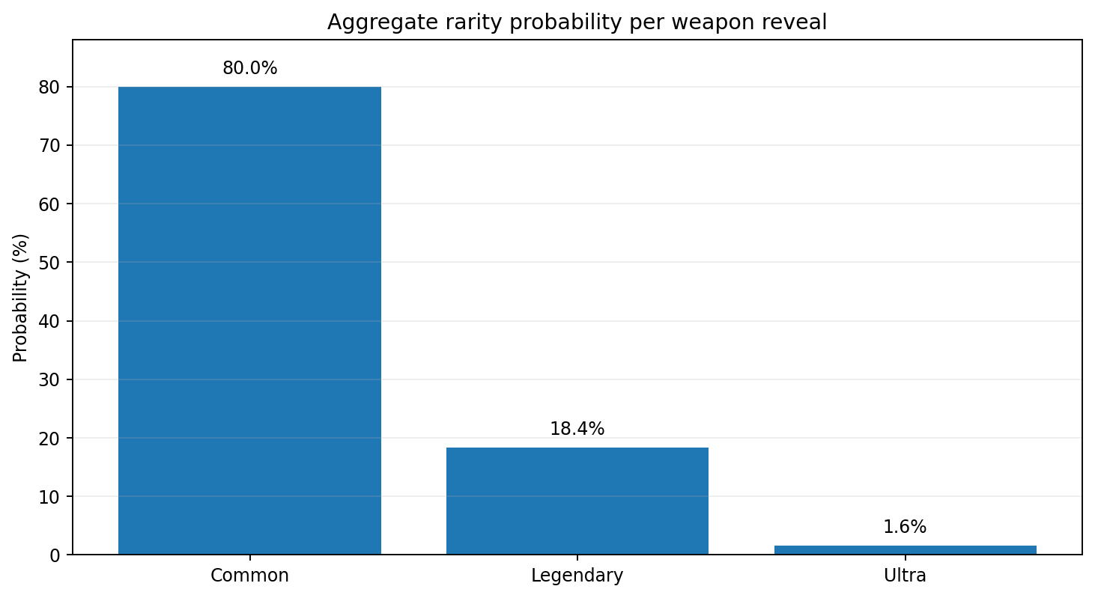
Aggregate of the official item-level drop-rate table; verify the live page before purchase.
Derived measure | Result | Assumption / limitation
At least one Ultra in three reveals | Approximately 4.7% | Assumes independent reveals and the posted 1.6% per-reveal Ultra rate.
At least one Legendary or Ultra in three reveals | Approximately 48.8% | Assumes independent reveals and a 20% non-Common rate.
Expected cash value | Not calculable from rates alone | Requires current box price, net sale prices, market depth, fees and liquidity.
LOOT-BOX RULE
Never use the rarity label as a proxy for value. Buy only after calculating net expected resale value from actual executable bids, not optimistic listings.

11 Deposits, wallets and withdrawals
Prove the entire money path before allowing the in-game balance to become material.
The current guide describes USDC-SPL deposits and withdrawals. BR1's Terms say a Cash Player may request a withdrawal when the account balance is at least $10, that processing may take up to seven business days, and that identity or anti-financial-crime information may be required. Older preseason material references a $25 minimum, so the live withdrawal screen must be checked. ^{[S8, S14]}

Safe first-withdrawal protocol
1 | Create a dedicated Solana-compatible wallet with no unrelated assets and no large balance.

2 | Confirm the exact token and network shown inside the official BR1 deposit screen. Do not send SOL or a non-SPL stablecoin based on an old article. ^{[S8, S14]}

3 | Deposit only enough for a very small lowest-tier test, after free-mode validation.

4 | Play until the smallest live withdrawal threshold is reached without increasing stake.

5 | Request the minimum withdrawal, record the timestamp and transaction identifiers, and wait through the stated processing window. ^{[S8, S14]}

6 | Confirm the received token is genuine USDC on the intended Solana address before adding more capital.

Custody and counterparty controls
- Keep only a working balance in BR1. The Terms permit investigation holds, suspension and termination, and contemplate forfeiture or loss of in-platform virtual items in certain circumstances. ^{[S8]}
- Never share a seed phrase, private key, one-time code or screen-share wallet approval with support or community members.
- Read every wallet signature. Reject blind signatures, unlimited approvals and transactions initiated from unofficial domains.
- Export a transaction ledger and screenshots after each deposit and withdrawal; preserve the account email and support ticket history.
THRESHOLD CONFLICT
Legal Terms currently say $10; older preseason references say $25. This almanac does not assume either figure will remain current. The live account interface and current Terms control. ^{[S8, S14]}

12 Security and anti-cheat risk
In BR1, cheating is not merely competitive unfairness - it is direct counterparty loss.
BR1's Terms prohibit bots, unauthorized or modified software or hardware, automated participation, collusion and outcome manipulation. A development vendor states that BR1 uses server-authoritative hit registration and live transaction processing. Server authority can reject certain falsified game-state claims, but it is not by itself a complete defense against aimbots, wallhacks, input automation, account farming or social engineering. ^{[S8, S16]}
TRANSPARENCY GAP
No public BR1 document reviewed named a dedicated client-side anti-cheat product, published detection statistics, described a victim reimbursement policy, or committed to reversing losses caused by later-banned cheaters. Treat that as an unresolved risk, not proof that no controls exist.

Evidence-preservation procedure
Trigger | Capture immediately | Action
Suspicious kill | Video clip, player name, time, server tier, kill feed, account balance before/after. | Stop paid play and file a support report.
Desync / severe latency | HUD, ping if visible, video of engagement, server region and timestamp. | Move to free mode; do not test with more paid spawns.
Withdrawal delay | Request screen, balance, destination address, ticket number and elapsed business days. | Do not deposit more; escalate through official support.
Unexpected wallet prompt | Full domain, transaction simulation, requested permissions and wallet address. | Reject, disconnect and verify through official site.

Common attack paths
- Fake invite, launcher or update links delivered through social media or a compromised community account.
- Wallet-drainer sites imitating the marketplace, loot-box page or token claim portal.
- Unofficial tokens using the BR1 name without a verified official mint address.
- Account-sale, boosting and rental arrangements that violate terms or create recovery disputes.
- Remote-access "support" scams requesting screen sharing, seed phrases or local files.

Terms-level platform risk
The current Terms include binding arbitration and a class-action waiver, allow withdrawal delays during investigations or eligibility verification, permit suspension or termination, and state a liability limitation that caps certain direct damages at CAD $50. Read the live Terms yourself before depositing. ^{[S8]}

13 Legal and U.S. tax checklist
The publisher's "skill-based" label is not a universal legal determination.

Eligibility
The Terms require players to be at least 18 and physically located in a jurisdiction where BR1 is permitted and unrestricted. They place responsibility on the player to determine whether paid entry, prizes, digital assets and tournaments are legal in the location from which the platform is accessed. ^{[S8]}
TRAVEL MATTERS
Eligibility may depend on physical location at the moment of play, not merely residence or account-registration address. Do not use a VPN or location workaround to evade a restriction. ^{[S8]}

Legal classification
BR1 calls itself a skill-based video game. Because the paid mode combines an entry fee, player performance and monetary prizes, gambling, paid-contest and digital-asset rules may still apply differently by state or country. The Terms do not guarantee legality in any jurisdiction. ^{[S8, S12, S17]}

U.S. tax recordkeeping
For U.S. taxpayers, digital-asset income must generally be reported, stablecoins are treated as digital assets, and the IRS treats digital assets as property. Cash prizes are generally taxable. Keep contemporaneous records rather than waiting for a tax form. ^{[S18, S19]}
Record | Why
Date and exact time of each reward / withdrawal | Supports fair-market-value and tax-year reporting.
USD value when USDC or an item is received | Establishes income amount and basis.
Deposits, spawn fees, platform fees and network fees | Supports reconciliation and professional expense analysis.
NFT / item purchase and sale price | Supports gain/loss and basis calculations.
Wallet addresses and transaction hashes | Provides auditable evidence of transfers.
1099 or platform statements, if issued | Reconcile against your own records; do not assume no form means no tax.
Tax characterization can depend on whether activity is recreational, prize income, a trade or business, or investment-related. A qualified tax professional should classify the activity based on actual facts.

14 Publisher and legitimacy assessment
Evidence of a real company is not evidence that every player can profit.
BR1 is published by 13904580 Canada Inc., operating as Bravo Ready. Public reporting identifies the company as Montreal-based. GamesBeat reported a $3 million raise in 2022 from investors including Solana Ventures, 6th Man Ventures, Shima Capital and Justin Kan. A 2023 company release announced a strategic Magic Eden investment and cited Krafton, 6th Man Ventures and Solana Ventures among investors. ^{[S8, S20, S21]}
Recent August 2026 reporting says the studio claimed cumulative player payouts above $100,000. That is meaningful evidence of operating activity, but the figure was not independently audited in the sources reviewed. ^{[S11, S13]}

Evidence matrix
Question | Evidence found | Assessment
Is there a real publisher? | Canadian legal entity, Terms, company site, named management and Montreal operations. | Yes, high confidence.
Is there a playable product? | Official download/signup and current beta/playtest reporting. | Yes, but access may be gated.
Is the economy documented? | Official guide publishes retention, ERB, Survival and extraction formulas. | Yes, with some conflicting live figures.
Are withdrawals contemplated? | Terms provide threshold, processing and verification language. | Yes; actual user experience still needs testing.
Are payouts independently audited? | No public reserve or payout audit located. | No / unknown.
Is anti-cheat fully documented? | Server-authoritative hit registration is disclosed; full anti-cheat stack is not. | Partial.
Is income dependable? | No; profitability depends on skill, access, opponents, rules, security and withdrawals. | No.
BALANCED CONCLUSION
The available evidence is stronger than an anonymous cash-game website and does not justify calling BR1 a scam. It is still far below the evidence needed to treat it as dependable income. The correct posture is a small, controlled experiment with a verified cash-out - not a large deposit or NFT purchase.

What would materially improve confidence
- A current public jurisdiction list and clear geolocation/age-verification policy.
- A named anti-cheat stack, enforcement statistics and a policy for losses caused by confirmed cheaters.
- Audited payout totals, segregated player-fund disclosures or verifiable reserve information.
- Consistent risk-tier, withdrawal and access information across the site, guide and client.
- Public player-count, queue-liquidity and regional-server data.

15 Seven-day onboarding plan
A deliberately slow test designed to answer the questions that matter before meaningful risk.
Day 1 - Verify | Create the account from the official domain. Read the live Terms, confirm age/location eligibility, access status, server schedule, risk tiers and withdrawal minimum. Deposit nothing.
Day 2 - Technical baseline | Install only the official launcher. Run free mode at the intended settings. Record frame rate, latency, crashes, input issues and any anti-cheat or security prompts.
Day 3 - Controls and map | Standardize five-slot inventory. Practice the five-minute Survival timer and 30-second exit. Map cover, loot and safe extraction positions.
Day 4 - Skill sample | Record at least 50-100 free lives. Calculate K/D, kills/hour, deaths/hour and Survival success. Do not infer paid profitability from a tiny hot streak.
Day 5 - Wallet and ledger | Create a dedicated wallet, verify USDC-SPL instructions in the live client, prepare a session ledger and set an entertainment-only bankroll.
Day 6 - Small paid test | Use the lowest available tier. Cap the entire day's loss at $5 or 5% of dedicated bankroll, whichever is lower. Stop immediately for latency or suspicious play.
Day 7 - Cash-out test | If eligible, request the minimum withdrawal. Do not increase stake until receipt is confirmed and at least 100 paid lives show positive net results.
PASS/FAIL TEST
Proceed beyond the test phase only after all four conditions are true: positive actual cash result, adequate sample size, completed withdrawal, and no unresolved legal/security/technical issue. A failure on any one condition means stop or remain in free mode.

16 Quick-reference sheets
The two-page field summary.

Formula card
Item | Formula / rule
Kill earnings | K x S x (0.80 + ERB).
Survival premium | 0.50 x S after successful Survival.
Net paid life | S x [K x (0.80 + ERB) - 1 + 0.50 x Survival] + secured cash + prizes - other costs.
Pure death-case break-even | 1 / (0.80 + ERB): 1.25 K/D at 0% ERB; about 1.05 at 15%.
Official planning threshold | 1.30 K/D base; 1.13 K/D at max ERB.
Almanac promotion threshold | 1.50+ base or 1.35+ max ERB over 100 paid lives, plus positive net and withdrawal proof.

Fast decision card
Condition | Action
One kill and Survival ready | Exit unless the next fight has a clear advantage.
Cash Drop acquired | Prioritize extraction.
Five-minute bar not full | Route toward a defensible future exit while avoiding forced fights.
High ping, desync or crash | Stop paid play.
Daily loss reaches 5% bankroll | End session.
Withdrawal delayed beyond stated window | Do not deposit more; preserve evidence and contact official support.
Token or NFT offered through DM | Assume scam until contract and domain are independently verified.

Glossary
Term | Meaning
ERB | Earnings Retention Bonus. Adds 0.5%-15% to the 80% base elimination retention.
Risk Server | Paid server tier in which each life has a spawn fee and elimination payout.
Free Server | Practice and leveling mode without a paid spawn fee.
Survival | Five-minute eligibility bar followed by an F10-triggered 30-second stationary exit.
Cash Drop | Looted cash value that must be secured through extraction.
USDC-SPL | USDC token on the Solana network used in the current deposit/withdrawal guide.
BR1 Points | Non-cash ecosystem points earned through activity and multipliers.
Operative | Playable character asset that can carry ERB and other attributes.
Infinite Pass | Seasonal progression track with XP and variable rewards.
Positive EV | Expected value above zero after every fee, cost and loss probability.

Due-diligence questions for BR1 support
Ask these before depositing more than a trivial test amount.
1 | Is access currently open at all times, invite-only, or limited to published playtest windows?

2 | Which risk tiers are live today in my physical jurisdiction?

3 | What is the exact withdrawal minimum, fee, processing target and supported destination method?

4 | Which anti-cheat technologies are active, and what happens to player losses after a confirmed cheater ban?

5 | Is identity verification required before deposit, before paid play, or only before withdrawal?

6 | Which countries and U.S. states are restricted for paid modes?

7 | Are player funds segregated from operating funds, and are payout reserves audited?

8 | What is the current official mint/contract address, if any, for a BR1 token?

9 | What are the current marketplace and rental fees, royalty rates and asset-transfer restrictions?

10 | How are server region, ping and match population disclosed before a paid spawn?

DOCUMENTATION STANDARD
Save the written answer, date, representative name and source URL. Community statements and old social posts are not substitutes for current Terms or a live client disclosure.

Methodology, change log and sources
Research hierarchy: current legal terms and official guide first; current third-party reporting second; old guides only for conflict detection.

Methodology
Research was conducted on 17 August 2026. Current official BR1 pages, legal Terms, guide pages, marketplace and loot-box disclosures were compared with recent reporting and historical financing coverage. Where sources conflict, the conflict is disclosed rather than silently resolved. Calculations use the official 80% base retention, 0%-15% ERB range and 50% Survival premium. They exclude unverified bonuses unless expressly stated.

Material change log / stale-guide traps
Topic | Older description | Current / safer reading
Survival timer | Ten-minute blue bar in older guides and community posts. | Current guide: five-minute yellow bar plus 30-second F10 countdown.
Elimination bounty | Older descriptions sometimes mention the greater of stake or 10% of a victim's accumulated earnings. | Current official examples use tier stake x (0.80 + ERB). Verify live client.
Settlement asset | Older articles refer to SOL or multiple chains. | Current guide describes USDC-SPL. Follow live deposit screen.
Withdrawal threshold | Older preseason material: $25. | Current legal Terms: at least $10; verify live screen.
Access phase | Open beta labels coexist with invite-only/timed-playtest reporting. | Assume account signup does not guarantee immediate server access.
Risk tiers | $0.10 and $0.50 appear inconsistently. | Use only tiers displayed in the live client.

Sources
[S1] BR1: INFINITE official homepage. BR1 / BRAVO READY; accessed 17 Aug 2026. https://www.br1game.com/ Open-beta label, core pay-to-spawn mechanic and homepage risk tiers.
[S2] BR1: INFINITE Overview. BR1: INFINITE Guide; updated Mar 2026; accessed 17 Aug 2026. https://litepaper.bravoready.com/br1-infinite-guide/br1-infinite-guide/br1-infinite-overview Free/risk servers and official profitability thresholds.
[S3] Elimination & Survival. BR1: INFINITE Guide; updated Mar 2026; accessed 17 Aug 2026. https://litepaper.bravoready.com/br1-infinite-guide/br1-infinite-guide/br1-game-ecosystem/elimination-and-survival 80%-95% retention, five-minute bar, F10 countdown and Survival premium.
[S4] Cash Drops & Extractions. BR1: INFINITE Guide; accessed 17 Aug 2026. https://litepaper.bravoready.com/br1-infinite-guide/br1-infinite-guide/br1-game-ecosystem/cash-drops-and-extractions Cash securing and official formula examples.
[S5] Earnings Retention Bonus (ERB). BR1: INFINITE Guide; accessed 17 Aug 2026. https://litepaper.bravoready.com/br1-infinite-guide/br1-infinite-guide/br1-game-ecosystem/earnings-retention-bonus-erb 0.5%-15% ERB range.
[S6] Weapon & Item Guide. BR1: INFINITE Guide; updated Mar 2026; accessed 17 Aug 2026. https://litepaper.bravoready.com/br1-infinite-guide/br1-infinite-guide/br1-game-ecosystem/br1-weapons/weapon-and-item-guide Weapon and item categories.
[S7] BR1: Operatives. BR1: INFINITE Guide; updated Mar 2026; accessed 17 Aug 2026. https://litepaper.bravoready.com/br1-infinite-guide/br1-infinite-guide/br1-game-ecosystem/br1-operatives Operative role and acquisition context.
[S8] Terms of Use. BR1 / 13904580 Canada Inc.; last update 25 Nov 2024; accessed 17 Aug 2026. https://www.br1game.com/terms Eligibility, withdrawals, verification, prohibited conduct, suspension and liability terms.
[S9] BR1 Infinite Pass. BR1: INFINITE Guide; accessed 17 Aug 2026. https://litepaper.bravoready.com/br1-infinite-guide/br1-infinite-guide/br1-game-ecosystem/br1-infinite-pass Preseason free access and possible future reward tiers.
[S10] BR1 Points. BR1: INFINITE Guide; accessed 17 Aug 2026. https://litepaper.bravoready.com/br1-infinite-guide/br1-infinite-guide/br1-game-ecosystem/br1-points Point-earning channels and multipliers.
[S11] Don't Miss These 5 Trending Play To Earn Games in August. PlayToEarn; 16 Aug 2026. https://playtoearn.com/news/dont-miss-these-5-trending-play-to-earn-games-in-august Recent beta/access description and studio payout claim.
[S12] BR1: Infinite Promises Players Real Money for Playing. Polygon; 7 Aug 2026. https://www.polygon.com/br-1-infinite-extraction-shooter/ Recent overview and gambling/cheating scrutiny.
[S13] BR1 Infinite: Extraction Shooter Offering Cash for Kills Draws Doubts. Insider Gaming; 7 Aug 2026. https://insider-gaming.com/br1-infinite-extraction-shooter-cash-for-kills/ Recent critical coverage and viral hourly claim.
[S14] Deposits & Withdrawals. BR1: INFINITE Guide; accessed 17 Aug 2026. https://litepaper.bravoready.com/br1-infinite-guide/br1-infinite-guide/br1-game-ecosystem/deposits-and-withdrawals USDC-SPL funding and payout flow.
[S15] Loot Boxes / posted drop rates. BR1; accessed 17 Aug 2026. https://www.br1game.com/loot-boxes Item-level Common, Legendary and Ultra rates.
[S16] Trostrum - BR1: Infinite project profile. Trostrum; accessed 17 Aug 2026. https://trostrum.com/ Server-authoritative hit registration and live transaction processing claim.
[S17] BR1: Infinite - real-money risk servers. PC Games Hardware; 9 Aug 2026. https://www.pcgameshardware.de/Spiele-Thema-239104/News/BR1-Infinite-Der-Extraction-Shooter-laesst-Spieler-auf-Risk-Servern-um-Echtgeld-kaempfen-1550621/ Current third-party review of gambling and anti-cheat questions.
[S18] Report digital asset income, including cryptocurrency, on your tax return. Internal Revenue Service; accessed 17 Aug 2026. https://www.irs.gov/newsroom/report-digital-asset-income-including-cryptocurrency-on-your-tax-return U.S. digital-asset income reporting.
[S19] Digital Assets. Taxpayer Advocate Service / IRS; accessed 17 Aug 2026. https://www.taxpayeradvocate.irs.gov/get-help/general/digital-assets/ Digital assets treated as property and taxable under general principles.
[S20] Bravo Ready raises $3M for BR1: Infinite Royale NFT game. GamesBeat; 11 Jul 2022; updated 20 Jun 2025. https://gamesbeat.com/bravo-ready-raises-3m-for-br1-infinite-royale-nft-game/ Fundraise and investor reporting.
[S21] BRAVO READY Announces Strategic Investment From Magic Eden. Business Wire; 30 Mar 2023. https://www.businesswire.com/news/home/20230330005710/en/BRAVO-READY-Announces-Strategic-Investment-From-Magic-Eden Company-issued investment announcement.
FINAL OPERATING RULE
Do not increase stake because a video says the game pays $10/hour. Increase stake only after your own ledger shows positive cash EV over a meaningful sample and your own withdrawal has cleared.

END OF INDEPENDENT RESEARCH EDITION

